Growing Area Research

Soil is a No-Go- any potting mix that includes compost or soil can increase the risk of soilborne disease

[Hardest to Easiest Seeds to Grow](https://www.nickgreens.com/post/2019/05/02/microgreen-seed-density-charts)

## Hydroponic Mediums-

* **Coir pith** (coconut fibre)- Waste product of the coconut industry, and is the husk of the coconut itself. Difficult to cut. OK water retention capacity. Large oxygen capacity. One word of caution about coconut fibre- there is a commonly available, lower grade of coconut fibre that is high in sea-salt and is very finely grained. This lower grade coconut fibre will produce disappointing results
* **Perlite**- Has been around for years. Used as a soil additive to increase aeration and drainage. It’s a mined material formed from rapidly heated volcanic gas. Commonly mixed with vermiculite. Inexpensive. Poor water retention capacity. Dust is harmful, so best to wear mask.
* **Vermiculite**- another mined material. Often used 50-50 with perlite. Inexpensive. Drawback is that its water retention capacity is too high to be used alone. Will drown the roots of the plant. Use a mask.
* **Soiless mix**- often a combination of Sphagnum moss, perlite, Zeolite and vermiculite. Most soiless mixes have a good combination of water retention and aeration
* **Sawdust** is tolerated by some microgreens. Depends on which tree it comes from, how fine a texture and how thick. Possible to mix in soil.
* **Felted jute grass** (Baby Blanket)- Very easy to cut and work with. Great water retention capacity and aeration. My family’s favorite non-soil medium. Disadvantage- expensive if not re-used. Can be re-used by sterilizing in boiling water.
* Grow Mats

# Sowing

When getting ready to sow, take seed size into account, as this will determine the best method of planting. Sifters and colanders can be used to help to sort seeds by size. Seeding densities should be thick enough to cover the flat, but not to the point of inhibiting air flow. Both small and large seeds should be sown thickly (⅛–¼" apart), then gently tamped into the growing medium.

Small seeds: 10–12 seeds/in2

Medium to large seeds: 6–8 seeds/in2

Seeding too densely can result in lack of air circulation, setting the stage for increased risk of disease.

## Covering and Watering

Small Seeds- covered with a layer of paper towels, finely sifted vermiculite, or a small amount of soilless mix

Large Seeds-covered with a light layer of the grow mix

* Water Gently
* Cover the flats with either a clear or white plastic dome to retain humidity and aid in germination
* If using paper towels, they should be kept moist and can be gently removed in just a few days. Most of the seed coats will be removed with the towel, which is helpful when it comes time to wash the final product.

## Seed Density

[Effects of Seed Density and Other Factors on the Yield of Microgreens Grown Hydroponically on Burlap](https://vtechworks.lib.vt.edu/bitstream/handle/10919/86642/Nolan_FinalProject_HydroponicMicrogreens.pdf?sequence=2&isAllowed=y)

Made use of Nutrient Film Technique (NFT) in study

References Johnny Seeds study shown above (JS uses soil)

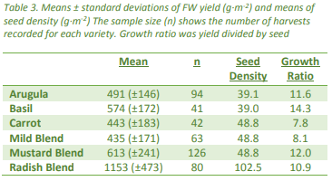

Basil has highest growth ratio(14.3 times mass from germination to harvest)

Seed Density

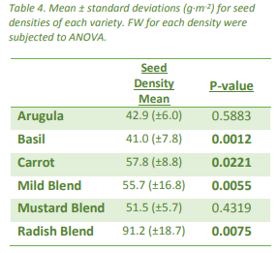

Different plants react differently when seed density is changed. Basil and radish are most affected by seed density (P value)

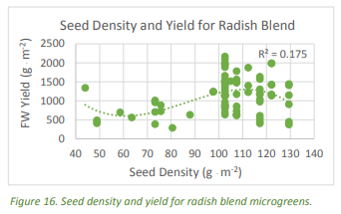

Example showing seed density for optimal growth for Radish blends

Days to Harvest

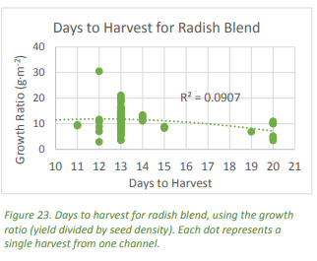

Number of days allowed until harvest can have influence on yield

Ex: Mustard blend produce greater yields the longer they grew(3weeks better than 2 weeks)

Radish blends (As shown above) produce more per seed when harvested young

Concludes with DTH better predictor of greater yields than seed density

Maybe focus seed density for circulation as opposed to growth

# Growing Area

Broccoli and Beets

[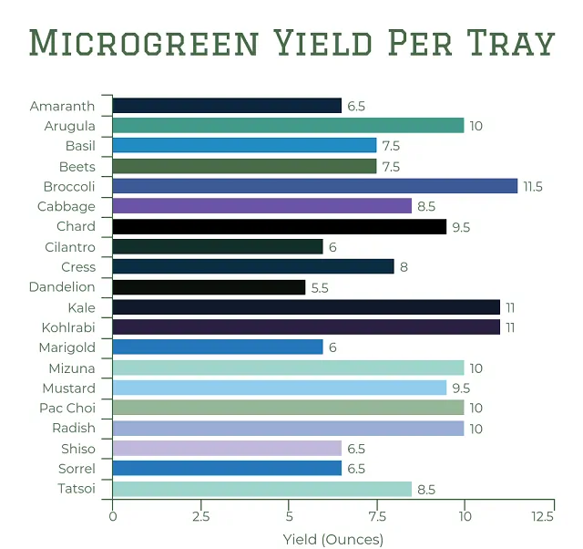](https://gardengearshop.com/microgreens-yield-per-tray/)